FORCES

Force - changes the motion of an object by either speeding it up or slowing it down, or it
changes the shape of an object.

Examples

1. The brakes on a car exert a force on the wheels to slow it down (directed backwards).

2. The engine of a car exerts a force through the wheels to accelerate (speed up) the car
(directed forwards).

3. When a football is kicked, the foot exerts a force on the ball that makes it go out of
shape.

Forces can act on objects either by direct contact or at a distance.

Those that act by contact do not always cause the object to move or change shape.

e.g. Pushing against the wall does not make the wall move or change shape.

These forces can also be classified as pushing or pulling forces.

Classifying Forces

DIRECT CONTACT | AT A DISTANCE
Pushing e.g. wheelbarrow | Gravity e.g. jump off a roof
Pulling e.g. Tarzan swing | Magnetic e.g. fridge door
Explosive e.g. bullet | Electrical e.g. static electricity
Friction e.g. brakes on car
Collision e.g. football

The unit used to measure forces is the Newton (N).

Balanced and Unbalanced Forces

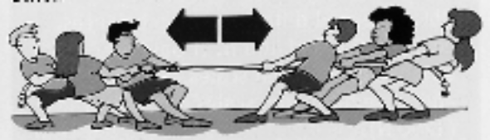
When two forces are equal and opposite, there is
no movement.

e.g. Two even teams in a tug-of-war.

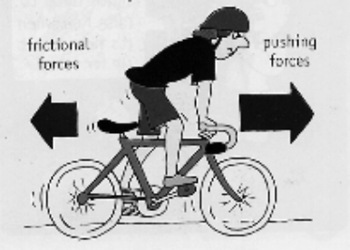

When bike riding, if the speed is constant, then
the frictional forces are equal and opposite to
the pushing forces of the rider.
When one force is bigger than the other, the object moves (accelerates) in the direction of the bigger force.

e.g. If the pushing forces of the rider are greater than the frictional forces, the bike
accelerates forwards.

